**Reply Letter**

Mar. 31, 2016

Dear Editor:

Thank you for your letter dated Mar. 22, 2016 and your comments on the paper entitled “An approach to achieving optimized complex sheet inflation under constraints” for the Journal of Computers & Graphics. The paper has been carefully revised in order to accommodate the reviewers’ suggestions and comments. The grammar issues are fixed, and new figures and paragraphs are added to address some technical issues. The following is the response/revision summary:

**For Reviewer 1:**

Thank you very much for your comments and suggestions. The grammar issues are all fixed according to your suggestions. The following is the response/revision for the technical issues.

***Comment 1.1****:*

*In the pdf that I downloaded, line 71 is missing. Thus the sentence that starts on line 70 as "The result is" is an incomplete sentence. Maybe this is a publishing problem, rather than an author problem???.*

**Response**:

It is a publishing problem. After adjusting the paragraphs and figures, we think it should be solved now.

***Comment 1.2:***

*Figure 5a, I printed out your paper to review it, and I can barely see the yellow if I look really hard. Even in an electronic version, it is hard to see. Either make 5a bigger or zoom in.*

**Response:**

Thank you for your suggestions. The figure has been revised as below:

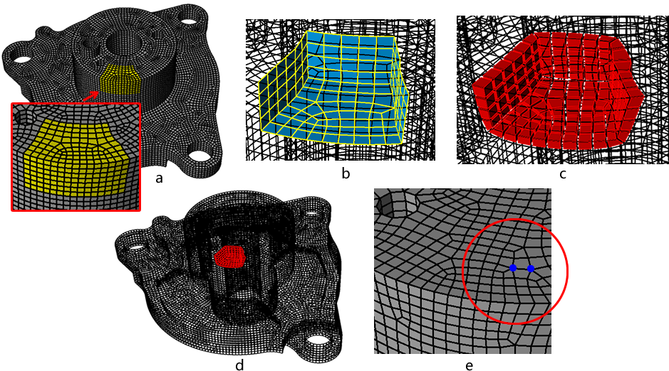

Figure 5: Reducing high valence by localized sheet inflation: (a) delimited region specified by a set of hex (yellow); (b) the localized quad set for sheet inflation; (c) the new sheet; (d) the new sheet is localized to the whole mesh; (e) the high valence is improved.

***Comment 1.3:***

*I don't see you define "local separation" anywhere in your paper. You first mention it on line 225, and then more with Figure 19, but you never define what it means. I think that "local separation" means that the boundary loop does not split the boundary into 2 separate sets of quads. Is this correct? Please clearly state that somewhere near line 225 where you first use that term.*

**Response:**

Thanks for your comments. New sentences are added to explain “local separation”:

“The first characteristic, which is also called local separation, means that the quad set separates the hex set that is local to the quad set into a certain number of hex subsets. It is necessary for a quad set to be inflatable, because the sheet inflation operation is actually done by separating the hex subsets and filling the gaps with new hexahedra...”(Sec. 3)

**Comment 1.4:**

*Line 571, the ideal valence of a boundary edge is not always 3, rather it is dependent upon the dihedral angle between the quads adjacent to that edge. If the angle is ~180, then 3 is optimal. if the angle is ~90, then 2 is optimal, ~270, then 4 is optimal, ~359, then 5 is optimal.*

**Response:**

Thanks for your suggestion. We’ve add new sentences and equation to explain it clear:

"For a mesh edge e inside the hex mesh, the ideal valence is 4 because this will make the average dihedral angle at the edge be 90◦. When e is on the mesh boundary, however, the ideal valence will be different depending on the dihedral angle θ between the two boundary quads adjacent to that edge, which can be calculated  using Equation 4.

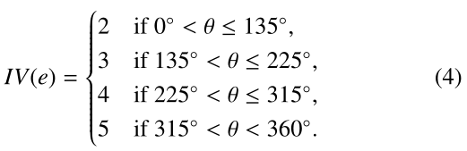

”(Sec. 5.1)

**Comment 1.5:**

*There is either a problem with equation 5, or you need to provide some example on how to use it. You say that if deltaVe is negative, it means the quality is improving. But how can that be because equation 5 includes variables from either before OR after the inflation, but not both. For example, using Figure 15d-f:*

*Before inflation:*

*||H1|| = 3*

*||H2|| = 1*

*ID(e) = ||e-4|| = ||4-4|| = 0*

*Therefore deltaVe = 2 + 2 - 0 = 4.*

*After inflation:*

*||H1|| = 3*

*||H2|| = 1*

*ID(e) = ||e5-4|| + ||e6-4|| = ||3-4|| + ||5-4|| = 2*

*Therefore deltaVe = 2 + 2 - 2 = 2.*

*So, a single deltaVe doesn't tell you if things improved. You would have to compare 2 deltaVe values. But equation 5 doesn't compare deltaVe values?????*

*Please fix the equation, or provide examples of computing values for the example in Figure 25, so we know how to use it.*

**Response:**

Thanks for your comment and suggestion. Since the equation is used to evaluate or predict the mesh quality after inflation, the new generated edges (e5 and e6) will not be calculated in the equation. To make it clear, we add new sentences in this paragraph:

“For ex-ample, in Fig. 25(d), IV(e4) = 4, so ID(e) = 0. ||H1|| = 1 and ||H2|| = 3, so ∆Ve= 3 + 1 − 0 = 4. ∆Ve> 0 means that this inflation makes the mesh quality worse. Note that we do not need to explicitly calculate the irregular degrees of e5and e6 since they are implicitly involved in ||H1|| and ||H2||.” (Sec. 5.1)

**Comment 1.6:**

*You have 2 examples of optimizing quad sets (Fig 27 & 28). However, neither of these have self-intersecting quad sets. Considering that your major contribution is sheet inflation for self-intersecting sheets, this is a problem. Are their special cases to consider when optimizing chords which run through edges at the self-intersection of the quadsets??? Add an example of optimizing a self-intersecting quadset.*

**Response:**

Thanks for your comment and suggestion. If the quad set is self-intersecting, we first separate it into individual quad subsets at the intersecting line, and then conduct optimization on each of them successively. We add a new figure and a new sentence to explain this:

“If the quad set is self-intersecting, we first split it into quad subsets at the intersecting line. For example, in Fig. 29, we separate the quad set into QS1 and QS2(Fig. 29(b)). Then we apply the above optimization algorithm on these quad subsets successively. The quads adjacent to the intersecting line (Fig.  29(c)) should keep unchanged in order to keep the topology valid.

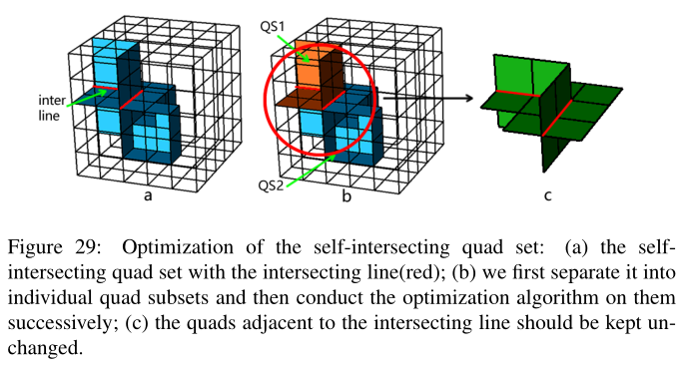

”(Sec. 5.2)

**Comment 1.7:**

*Figure 38. What algorithm did you use to generate the hex mesh on the bunny. Is it a hex mesh, or just a quad mesh of the boundary. I know that one of the other reviewers asked you to use the standford bunny as an example model, but the bunny is a test case primarily used by the computer graphics community, where they only really care about the boundary quads. Your paper is focused on mechanical models, so the use of the standford bunny seems an odd choice to me.*

**Response:**

It is a hex mesh. It is generated by using a frame-field-based algorithm with the help of one of my colleagues.

**Comment 1.8:**

*Table 1. This table seems out-of-place. Did Mitchell, Staten, and Chen provide you with their implementations? You state that they "Failed", which suggests that you did run their code and it failed. However, I know Mitchell, and he didn't give you any code. If you attempted to implement it yourself and your implementation of Mitchell/Staten failed, then are you sure it isn't because of a bug in your code??? Chen is your colleague, so it makes sense that you have his code, but I recommend you find a different way to present the "Failed" status of Mitchell and Staten. A statement about Mitchell's Pillowing such as "Does not support self-intersecting sheets" is sufficient. For Staten, a statement such as "Insufficient details to implement" is again sufficient.*

**Response:**

Thanks for your suggestion. The table has been revised as below:

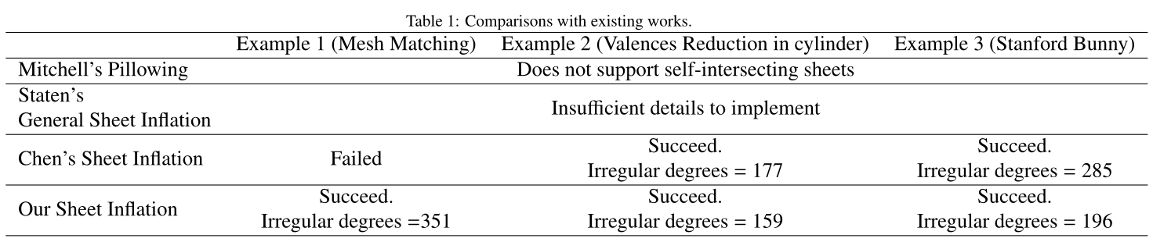

**For Reviewer 3:**

**Comment 3.1:**

*line 71 is missing.*

**Response:**

This publishing error should be fixed now. Thank you for your comment.

**Comment 3.2:**

*figure 4 has an image e but not included in the caption nor in the explanation from line 72 to 80.*

**Response:**

Thanks for your suggestion. The caption of Fig. 4 has been revised:

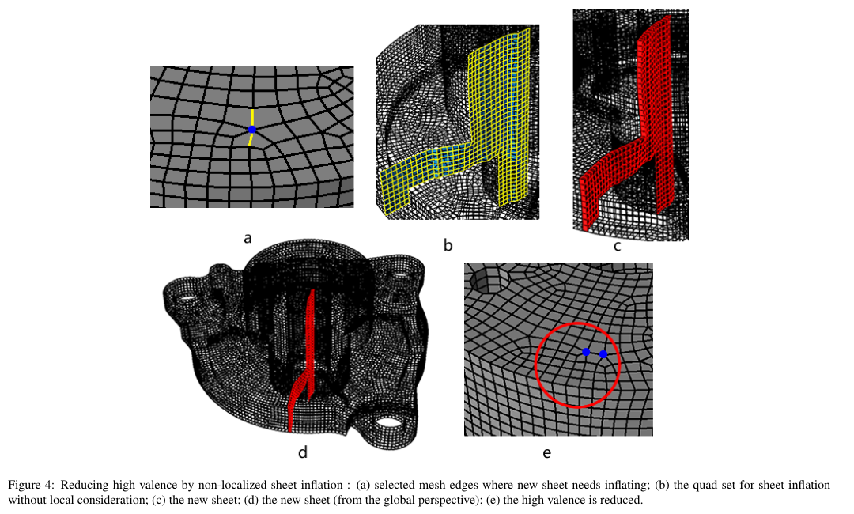

**Comment 3.3:**

*Figure 4d and 5d are compared to each other, but the orientation of the mechanical part doesn't match.*

**Response:**

Thanks for your suggestion. Fig. 4d has been adjusted to shared the same orientation with Fig. 5d.:

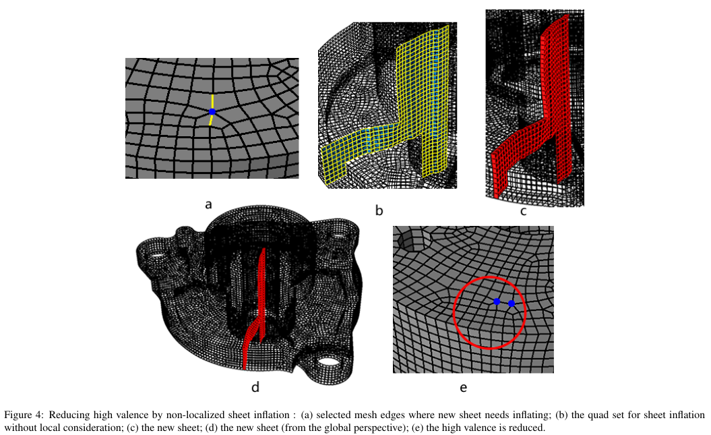

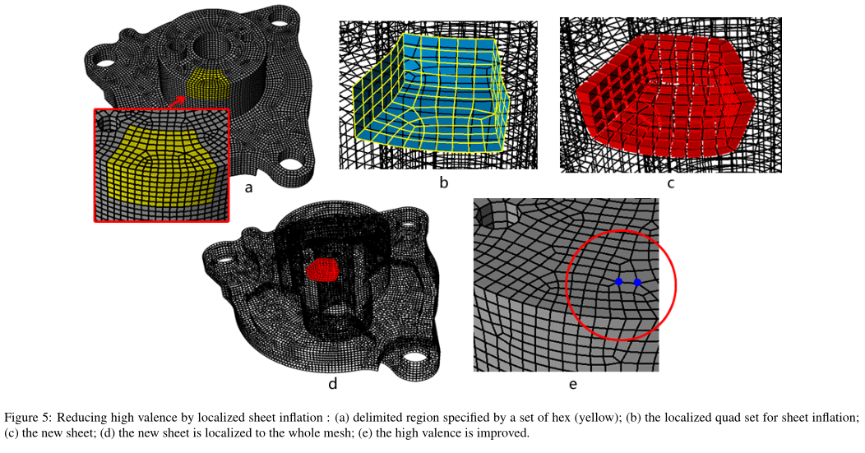

**Comment 3.4:**

*Figure 6 has image c with no caption.*

**Response:**

Thank you for your comment. The caption of Fig. 6 has been revised:

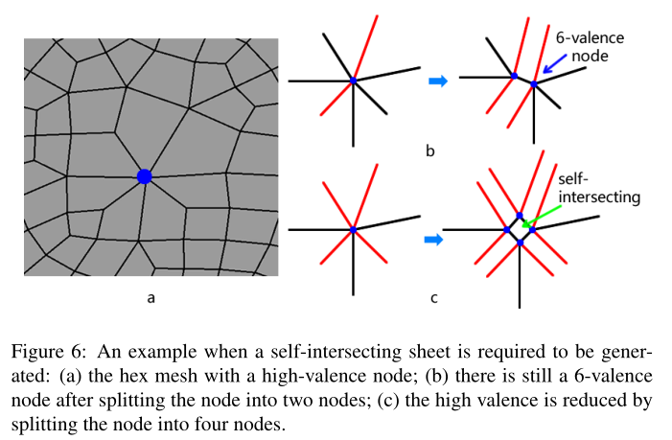

**Comment 3.5:**

*Line 458 needs to be re-written.*

**Response:**

the sentence has been rewritten as "Similarly, for each of t's adjacent nodes, there is one directed edge from this node to t." (Sec. 3.3)

**Comment 3.6:**

*Line 794 -- 794 needs to be rewritten to connect self-intersecting to mesh quality. Why/when does Chen's method produce low mesh quality?*

**Response:**

Thanks for your comment. These sentences have been revised as:

“Although Chen's Sheet Inflation can inflate sheets that self-intersect only once, the mesh quality suffers from their optimization algorithm due to the fact that their optimization algorithm is based on simply handling concave/convex mesh edges. Our approach can achieve better mesh quality thanks to the new chord-based optimization algorithm.”(Sec. 6.3)

**Comment 3.7:**

*Can more self-explanatory names be given to "example 1" and "example 2" in Table 1?*

**Response:**

Thanks for your suggestion. The table has been revised. Please refer to the response for Comment 1.8.

Finally, it is our pleasure to have our paper being considered to publish in Computers & Graphics. Please do not hesitate to contact us if you need further information or work.

Sincerely yours,

The authors